PARISH PROFILE 2026
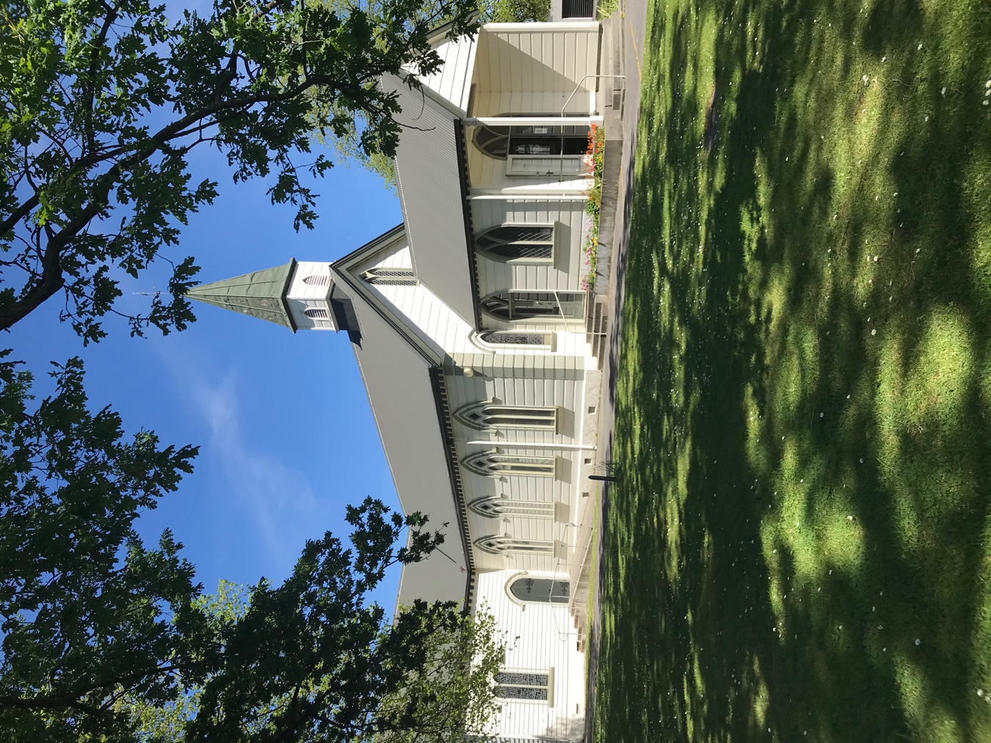
ST MARK’S CHURCH
CARTERTON

Contents
Introduction 3
Section 1: Our Mission Action Plan 4
Section 2: Worship at St Mark’s 5
Sunday worship 5
Mid-week worship 6
Morning prayer 6
Rest home services 6
Section 3: Parish groups and activities 7
Clergy 7
Vestry 7
Churchwardens and administrator 7
Finance subcommittee 7
Home groups 7
NextGen 7
EFM (Education for Ministry) 8
St Mark’s Fellowship 8
Fruit and Vegetable Co-op 8
Car Boot Sale and Little Parish Bookshop 8
Seasons for Growth 8
Annual Church Fair 9
Carter Society and Carter Court 9
Users of our hall facilities 9
Section 4: Parish staffing 10
Section 5: St Mark’s: The numbers 11
Finances 13
Section 6: A Short History of St Mark’s Church 14
Section 7: The Carterton Parish and District 15

Introduction
St Mark's church in Carterton is a family-friendly parish that loves to worship the Lord and to meet the challenges of the ever-changing world around us. We have a Mission Action Plan that was unanimously endorsed by the parish in 2022. It is time to review this plan, but before doing so we are undertaking a process of prayerful discernment in order to discover what God wants for us and from us. So at this point in time, we are exploring our purpose and mission.
Our previous priest-in-charge, Hennie Nothnagel, left at the end of January this year (2026). Currently we can support a 0.5FTE priest-in-charge. We are blessed with having an interim priest-in-charge, Sam Bate, and with ordained and lay members of our congregation who are willing to support and help our leader.
Our current rhythm of worship is:
- an 8.00am service in the church and 9.30am café church in the hall on the first Sunday of the month
- 9.30am service every other Sunday
- a Eucharist service at 10am every Thursday.
We also offer monthly Eucharist Services at Carterton’s two local rest homes.
We have five house groups that meet weekly and a vestry that meets each month. St Mark’s Fellowship has a monthly meeting for those wanting fellowship and connection within the church. We have a number of regular outward-facing initiatives such as a monthly shared meal, monthly car boot sales, weekly Fruit and Vegetable Co-op, and the Seasons for Growth programme for children and others who have experienced trauma, loss or grief.
Demographically we are a mix of young, middle-age, and mature believers. We like to think of ourselves as a congregation of wise heads and youthful hearts, keen to do all we can to share and spread the Good News.
Carterton is the service town for the mainly agricultural industries in the district. It also serves as a commuter hub for the city of Wellington, and so is growing steadily. It’s a small town with a strong sense of community and a warm welcome always for visitors. We have our own district council and an excellent events centre that attracts local and national shows. There’s good schooling (and early childhood education) here and in Greytown and Masterton (each about 15 minutes away), and plenty of outdoor activities for the whole family. It’s a great place to live.
We invite you to join us in serving this community. We look forward to exploring with you whether God is calling you to serve as our next leader, so that together and equipped by faith we can truly serve God in Carterton Carterton. We are praying for you.

Section 1: Our Mission Action Plan
In 2022, after a period of group discussion and discernment, we published our five-year Mission Action Plan (MAP). The aim was to set a clear future direction for our parish and to ensure that our hopes and vision for the coming years were consistent with the diocesan vision and values.
St Mark’s leadership and vestry then set about planning and implementing processes to achieve the key goals of the plan. The plan has been a standing item on the agenda at each parish AGM.
We undertook to review the Mission Action Plan at the end of 2025, and will now do so in 2026 as part of a wider process. We have committed to a process of prayerful discernment in order to discover how God wants us to move forward. Our interim priest-in-charge, Sam Bate, is leading this process.
If you would like to read the Mission Action Plan, you can do so by either:
- opening the PDF that came with this profile
- accessing it on our church website.
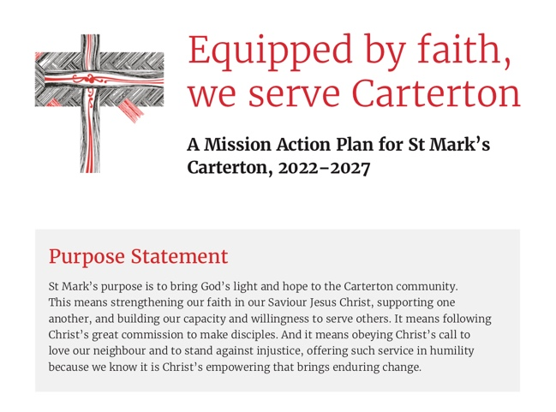

Section 2: Worship at St Mark’s

Sunday worship
The liturgy for our regular Sunday worship is grounded in A New Zealand Prayer Book – He Karakia Mihinare o Aotearoa (ANZPB-HKMOA) and draws on other seasonal liturgical resources, mainly from around the Anglican Communion. Our 9.30am Sunday services include the opportunity for 1:1 prayer ministry in our side chapel during Communion.
- 8am worship, once a month on the first Sunday of the month, is about 45 minutes, has a gentle reflective atmosphere and is followed by breakfast in a meeting room off the parish hall.
- Also on the first Sunday of the month, we have café church at 9.30am. This is a much more informal service in the hall. It has been much appreciated and has drawn a number of new families and people to St Mark’s.
- If there are five Sundays in a month, the fifth Sunday is a Family Service in the Church.
- On other Sundays, 9.30am worship lasts about 1 hour. It includes music – a mixture of traditional hymns and more contemporary songs – and is followed by morning tea.
- NextGen is our programme for primary and intermediate children, held twice a month during the 9.30am service.
- Once each school term St Mary’s Roman Catholic School in Carterton celebrate their school mass in St Mark’s.

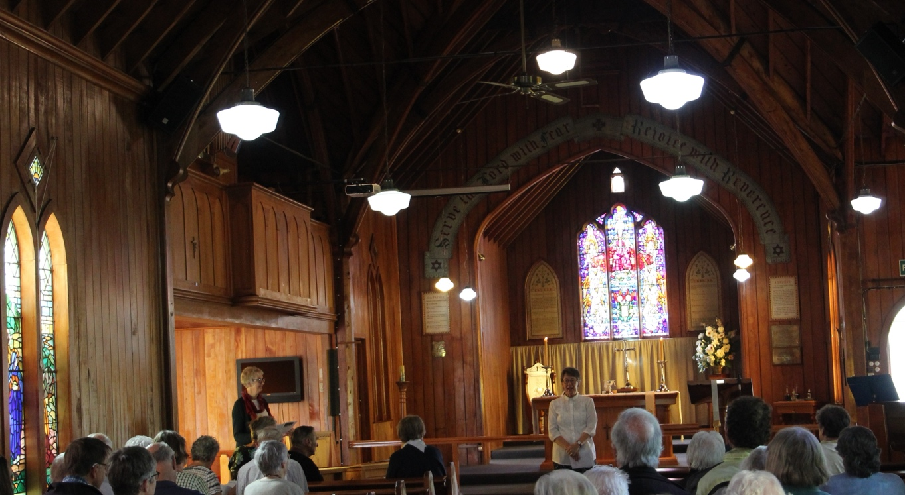

Mid-week worship
Our Thursday Eucharist at 10am offers an opportunity for mid-week worship. It uses the eucharistic liturgy for small groups from ANZPB-HKMOA, has a reflective atmosphere with a short homily, lasts 30-40 minutes, and is followed by morning tea in the church. Some regular mid-week members also worship on Sundays; for others the mid-week Eucharist is their primary worship service. On the first Thursday of the month the laying on of hands and anointing is also offered.

Morning prayer
Members of Wairarapa Anglican parishes, including St Mark’s, join in prayer each week on Tuesday, Wednesday and Thursday mornings, via Zoom.

Rest home services
St Mark’s leads a Eucharist at our two local rest homes, Carter Court and Roseneath, on the third Wednesday of the month.

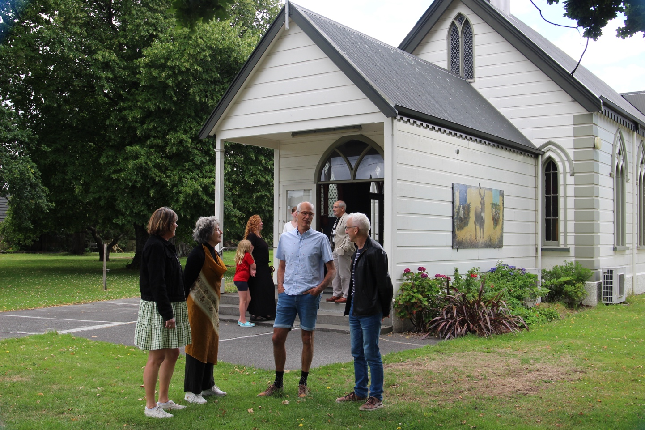

Section 3: Parish groups and activities

Clergy
We are very fortunate to have Reverend Sam Bate serving as our interim priest-in-charge. We are also blessed to have in our parish community Reverend Judith Wigglesworth, who regularly presides and preaches at services.

Vestry
Our current vestry was elected in December 2025 and comprises our interim priest-in-charge, our two churchwardens, our synod representative, and three other lay people from the parish.
Vestry meets monthly, currently on the third Thursday of the month at 7pm, in the church hall. We alternate business meetings with gatherings focusing on spiritual formation, as we seek to deepen our connections with God and with one another, and to prioritise vestry’s calling as a praying group of disciples.

Churchwardens and administrator
Our people’s warden is John Wilkinson, our bishop’s warden is Simon Chiaroni, and our parish administrator is Roger Wigglesworth. They meet once a month with Reverends Sam and Judith, to share, reflect, pray, and discuss current matters relating to the parish.

Finance subcommittee
A group comprising the bishop’s warden, the treasurer, and the administrator meet every two months ahead of the vestry business meeting to analyse the parish’s latest finance figures and discuss finance matters. Their recommendations, decisions, and report are brought to vestry for ratification.

Home groups
There are five regular home groups meeting on Monday and Tuesday mornings and Tuesday and Wednesday evenings in people’s homes.
These home groups meet a desire for small-group fellowship and personal spiritual growth among many parishioners. They take a variety of approaches in their meetings, sometimes following a common study (e.g., during Lent) and at other times choosing their own focus. Some groups use the house church liturgy created by the diocese in 2020 during Covid, and spend time discussing the gospel reading for the upcoming Sunday.
Now that small groups have become an established part of parish life, there is scope to multiply our network of home groups, increase the discipling focus of the groups, create a more intentional mission focus for each of them, and invite more parishioners to become involved.

NextGen
This programme aimed at primary and intermediate children is supported by three leaders on rotation and is held in the meeting rooms off our church hall. Attendance varies from 1-2 up to 10.
In 2026, we hope to start a “Choc and Chat” group for college-age teenagers that will meet in a local coffee shop to talk about Jesus, life and faith.
We also co-hosted a Wairarapa-wide Youth Alpha course in the first few months of this year.

EFM (Education for Ministry)
During 2025 the parish hosted two Education for Ministry courses: the four-week Faith Grounded in the Whenua course and the twelve-week Church in Aotearoa New Zealand course. There are three qualified EFM trainers in the parish. We hope to offer more EFM courses in 2026 and beyond.

St Mark’s Fellowship
Fellowship is a group within the parish that meets on the third Wednesday of the month in the parish hall. There is a guest speaker each month, a sales table, and a monthly raffle. Most members of Fellowship are St Mark’s parishioners; for others Fellowship is their main connection with St Mark’s. Funds raised during the year by Fellowship contribute to supporting Child-Fund children sponsored by the parish.

Fruit and Vegetable Co-op
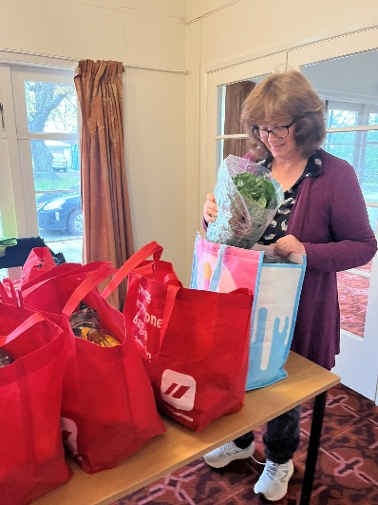
The Wairarapa Fruit and Vegetable Co-op is part of a network of co-ops across the wider Wellington region. Members of St Mark’s have been involved in the co-op since early 2021. A St Mark’s coordinator rosters a team of about eight volunteers for packing, transport, and pick-up of the orders from St Mark’s each Wednesday, 3.30-4.30pm.
The co-op has grown from small beginnings to become one of our key mission outreach activities. The pick-up hub in our church hall enables us to connect with people in our community every Wednesday afternoon. Since mid-2021, demand in our local community has increased significantly, with the number of regular weekly orders today ranging from 35 to 55, depending on the season.

Car Boot Sale and Little Parish Bookshop
During 2021 two ideas as potential missional connection points with our local community gained momentum: a car boot sale and a parish bookshop. It was envisaged that a car boot sale would make use of our spacious grounds and encourage members of the community to come along and sell their surplus household goods; and that a bookshop would enable us to turn our stockpile of surplus books from recent church fairs into a community resource.
Our first car boot sale and bookshop opening was held in late 2021, and since then it has become a monthly event on the first Saturday morning of the month. The event has proved to be a fruitful connection and conversation opportunity with locals, as well as a useful fundraiser.

Seasons for Growth
For a number of years the Seasons for Growth Wairarapa programme has run out of St Mark’s. Our Anglican diocese partners with the Catholic church to offer the programme in our region. We employ a coordinator part-time to plan and manage support for groups of children, young people, and adults who have experienced trauma, loss, or grief. The programme enables connections with schools and members of the community. Although under the umbrella of St Mark’s, the programme is self-sustaining and proactively makes regular grant applications to community trusts.

Annual Church Fair
St Mark’s has a tradition of running a parish fair in October/November each year. This is always popular in the local community and for many years has been very successful as a fundraiser.

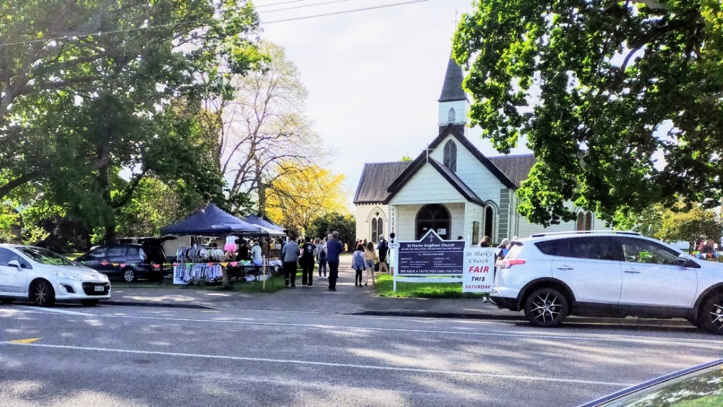

Carter Society and Carter Court
St Mark’s has a close relationship with the Carter Society, a local non-profit trust which was established in 1960, though the relationship with Carter Court has roots that go back much further. The Carter Society owns Carter Court, an aged care residential facility, and a number of social housing units in the community.
Clergy and lay people at St Mark’s have traditionally been chaplains to Carter Court and members of the Executive Board. As well as the regular monthly Eucharist service, the chaplains are invited from time to time to pray with residents who may be nearing end-of-life, and to bless rooms following the death of a resident.

Users of our hall facilities
- Tai Chi, two exercise groups that each meet once a week
- Pippins and Brownies, which meets on Thursday afternoons
- Alcoholics Anonymous, which meets most Friday evenings
- St Mark’s Indoor Bowls, which meets on Monday evenings
- Guides, which meets on Monday afternoons
- The Carterton Crier Committee, which meets monthly on Thursday mornings

Section 4: Parish staffing
Rev Hennie Nothnagel served as 0.5 (half-time) priest from late 2023 to early 2026. Sam Bate, our current interim priest-in-charge, is working on 0.4 FTE basis.
Reverend Judith Wigglesworth assists in the parish on a voluntary basis, presiding at one Sunday and two Thursday services a month. If both Sam and Judith are unavailable for a Sunday service or there is a fifth Sunday in the month, a visiting priest from another parish in the Wairarapa is invited to lead worship and preach at St Mark’s.
Parish administration is coordinated by Roger Wigglesworth on a volunteer basis. We are endeavouring to gradually spread the load of the many parish administrative tasks.
Currently on Sundays, preaching is spread across Sam, Roger, Judith and several of our gifted parishioners. Sam is also seeking additional potential lay preachers from within the Parish who may be sensing a call to this ministry,
We are fortunate to have a strong committed team of volunteers. They act as liturgical assistants, serve on our very active pastoral care group and manage our banking, finance, sanctuary care, gardens, and property and maintenance. We are blessed with having several musicians who play for Sunday worship. We also have a paid part-time cleaner.
St Mark’s pays the leader of the Seasons for Growth programme on a part-time basis, with the salary covered by successful funding grant applications.

Section 5: St Mark’s: The numbers
We have approximately 300 on our wider parish roll, with approximately 100 of those attending services at least 10 times a year.
Our typical regular attendances figures are:
- Sunday worship: 55
- Thursday worship: 12

DEMOGRAPHICS (for regular attendees in November 2025)
We are a predominantly NZ-European congregation, and around 65% of us qualify for Gold Cards.
Age | 0-9 | 10-19 | 20-29 | 30-39 | 40-49 | 50-59 | 60-69 | 70-79 | 80-89 | 90+
Percentage | 5 | 7 | 3 | 1 | 6 | 11 | 18 | 25 | 23 | 1
Ethnicity | NZ  European | Maori | Other  European | Chinese | Indian
Percentage | 90 | 1 | 8 | - | 1
Length of time regular attendees have been in the parish | 0–5 years | 6–10 years | 11–20 years | 21+ years
Percentage | 45 | 20 | 9 | 26

Finances
As with many parishes these days, it has sometimes been challenging for us to balance our annual budget. We have managed to do so due to active fundraising, drawing down some capital, and postponing some non-urgent aspects of maintenance on our buildings and grounds.
Our current financial situation has stabilised and enabled us to address some of the delayed maintenance. We are able to offer a 0.5 FTE stipend for a future priest-in-charge.
Total expenditure has been pretty consistent since 2010. A significant portion of it has been used for paying clergy stipends and meeting accommodation costs for clergy. The next most significant expense is property, which consists of R&M for the church, a ‘vicarage’ (currently let to the Wairarapa Safer Community Trust), and a parish hall (which includes an office for the priest and administrator). (The church buildings are located on a corner section which is 2.5 acres (1 hectare) in size. We continue to explore possibilities for leveraging this vacant land.)
Our income is predominantly from offerings from the congregation, which have been reasonably consistent over the last five years. Most giving is by direct credit. Rental income from the vicarage was about the same amount as the expenditure on accommodation for the priest. Fundraising has significantly increased in the last three years, with social events, car boot sales, Trade Me sales and the fair all part of the annual cycle. Vestry is currently exploring the development of a bequesting programme.
Below are summary graphs for our most recent complete financial year, 2025.
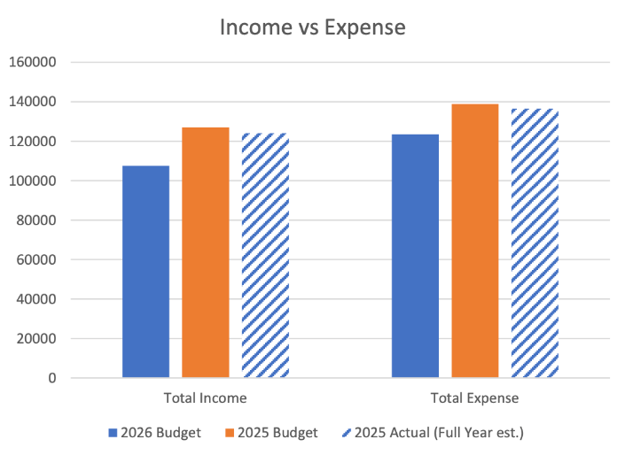

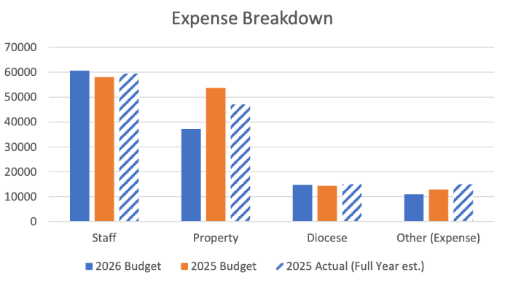
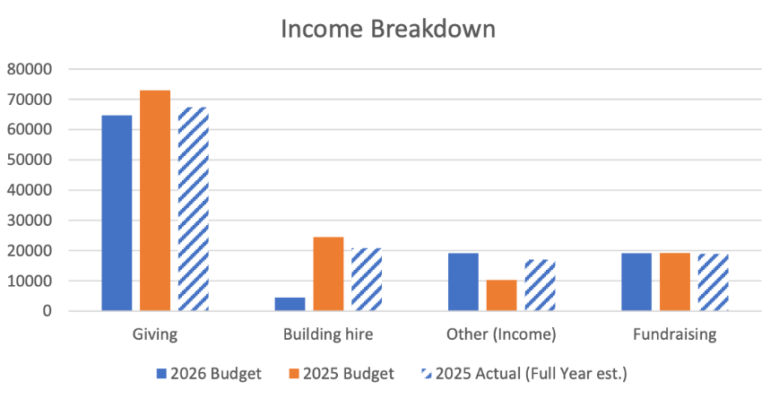

Section 6: A Short History of St Mark’s Church
Our wooden church has been the heart of Anglican worship in Carterton for over 150 years.
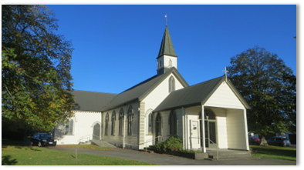
A half-acre section was gifted in 1873 by William Walker and the church was built by Thomas Bennett for £210. The first service was held on 21 February 1875 and the building was consecrated by Bishop Octavius Hadfield and dedicated to St Mark on 3 May 1875.
A Sunday School building was also built on the site, at the same time as the church. It was moved further back to make room for enlarging the church in 1882 and has become part of the Parish Hall.
The church seats up to 100 persons, has a side chapel in the crossing, a good quality pipe organ, and several renowned stained glass windows.

Section 7: The Carterton Parish and District
The St Mark’s parish boundaries are the same as the boundaries for the Carterton district.
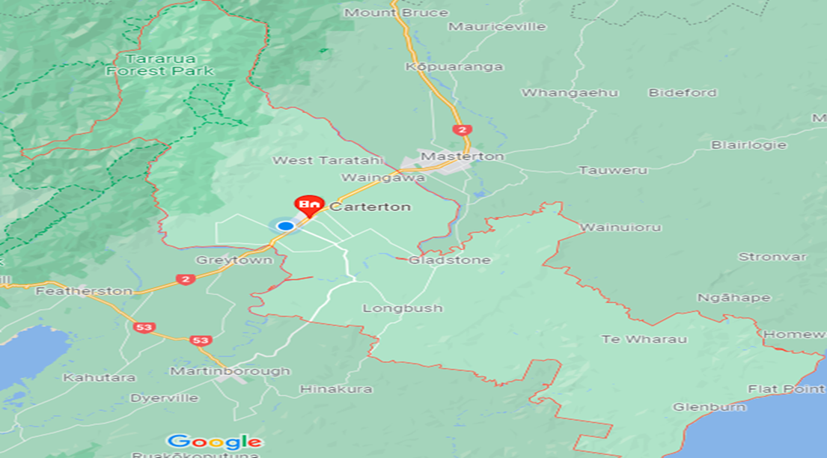
Carterton (Taratahi) is located 14 km southwest of Masterton and 80 km northeast of Wellington. The town has a population of approximately 6,000, with a total district population of over 10,000.
Carterton was founded in 1857. Originally known as Three Mile Bush, it served as housing for workers building the road between Wellington and Masterton. It was later renamed after Charles Carter, a local landowner and MP.
Dairy, wool, beef, and lamb farming are the predominant industries, and there have been new agricultural ventures such as deer, dairy goats, and manuka honey industry. On the drier lands to the east of the town, in the Gladstone and East Taratahi regions, a number of vineyards have been established since the mid-1980s. Other crops such as olives are also finding favour, particularly with newer residents living on lifestyle blocks.
Carterton is a service town with many businesses operating at least 6 days a week. Its main street has retained an unpretentious character. Many of our population commute to Wellington for work.
A total of six primary schools serve the District along with an extensive medical centre and two dental practices. Secondary school students usually attend Kuranui College (Greytown) or one of the state or Anglican integrated schools in Masterton.
Carterton District annual events include the annual Daffodil Festival held every September, the Scarecrow Festival held every November, and the Wairarapa International Balloon Fiesta held around Easter. Carterton has the largest Events Centre in the Wairarapa, an attractive modern venue that caters to a wide range of community services, events, and visiting shows.
Local leisure pursuits include wetlands and bush walks, swimming in river holes, mountain biking, kayaking, fishing, and horse riding.
As a part of our Mission Action Plan we collated a detailed assessment of the Carterton District. It is available as a separate document included in the profile package.

